Nursing Monitoring System-Base on IOT with Big Data Analytics

**Abstract:**

Present day systems use sensors that are hardwired to a Pc next to the bed. The use of sensors detects the conditions of the patient and the data is collected and transferred using a microcontroller. Doctors and nurses need to visit the patient frequently to examine his/her current condition. In addition to this use of multiple microcontrollers based intelligent system provide high level applicability in hospitals where a large number of patients have to be frequently monitored. For this here we use Internet of Things (IOT) with wireless applicability and providing each patient a unique ID by which the doctor can easily identify the patient and his/her current status of health parameters. Using the proposed system, data can be sent wirelessly to the Nursing Monitoring System (PMS) allowing continuous monitoring of the patient. For a hospital treatment with IOT-based system, hospital staffs always have to keep track and pay much more attentions to the raw medical records of individual patients instead of directly making diagnosis or treatment. And this data also would help to analyze the patient’s health. However, such medical data cannot be directly use for forward analyzing and presenting because this data are not gathered in proper manner or not in summarize way. This is the point where the role of big data in IOT comes into the picture. Big data analytics is emerging as a key to analyzing IOT generated data from connected sensors which helps to take the initiative to improve decision making.

**Index terms**: Internet Of Things (IOT), Big Data (BD), Nursing Monitoring System (NMS), Health Monitoring, patient Id (PID).

1. **Introduction**:

Health monitoring is the major problem in today's world. Due to lack of proper health monitoring, patient suffer from serious health issues. There are lots of IOT devices now days to monitor the health of patient over internet. Health experts are also taking advantage of these smart devices to keep an eye on their patients. With tons of new healthcare technology start- ups, IOT is rapidly revolutionizing the healthcare industry. Most hospital administrators are concerned about patient security. Giving care and health assistance to the bed ridden patient's at critical stages with advanced medical facilities have become one of the major problems in the modern hectic world. In hospitals where a large number of patients whose physical conditions have to be monitored frequently as a part of diagnostic procedure the need for a cost effective and fast responding alert mechanism is inevitable. Proper implementation of such systems can provide timely warnings to the medical Staffs and doctors and their service can be activated in case of medical emergencies.

Notably, IOT is an Internet-based paradigm that includes several interconnected technologies for the information exchange between devices, generally small ‘‘things’’ of the real world, that can be identified and monitored through the Internet.IOT implementation must take into account different factors depending on the application context. Data produced by sensors must be processed, interpreted, stored. And the choice of data store system or data analyzing each plays important role for the success of an application, such as choosing the best Data Base Management Systems (DBMS) for storing the data gathered by sensors [1].

In this work, architecture of an NMS based on the IOT and BD proposed. The three-layered architecture integrates Fog and Cloud Computing capabilities to support both diagnosis and storing the well summarized data of patient’s medical record .In addition, this will also provide different services like’s real-time alert notifications, remote health monitoring, information visualization and data analysis. The proposed system envisions assisting health professionals in medical decision-making. For monitoring patient health we used the ultra sonic sensor for the patient saline level detection and with the help of heart beat sensor we could calculate the patient pulse, using the IOT technology we are possible to store these data for analyze and monitor patient health remotely. Our goal is to help big hospitals to watch patient health status flexibly and also providing the hospital rooms managements.

1. Objective

* The main objective is to design a Nursing Monitoring System to help the nurses and doctors for monitoring patient health and provide proper treatment by using generated data
* To detect the heartbeat of patient and keep track of pulse and warn the nurse in emergency, when it is low or high than normal pulse.
* To detect the saline level and keep track of level and warn the nurse in emergency, when it come to end or specified level which we had set.
* Try to gather well organize and summarize data form IOT sources.

1. **PROBLEM DEFINATION:**

A remote health monitoring system is an extension of a hospital medical system where a

patient's vital body state can be monitored remotely. Traditionally the detection systems were only found in hospitals and were characterized by huge and complex circuitry which required high power consumption. Continuous advances in the semiconductor technology industry have led to sensors and microcontrollers that are smaller in size, faster in operation, low in power consumption and affordable in cost.

* Hospitals need remote monitoring system to check patient health with low cost and better reliability.
* Generated data from senores must be stored in proper summarized manner for better data visualizations.
* Hospital should provide system, which will help the nurse or cleaning staff to track patient health and room services.

1. Related work.

In [2], ultrasonic is used to detect level of any liquid. These liquids may be oil, chemical, meteorological industry, and so on. Ultrasonic technique has many advantages over the mechanical, optical, electrical and electromagnetic ways. Advantages like low cost, high linearity and good repeatability. Most important feature of ultrasonic is that it is used to detect the level of liquid regardless of liquid type.

In [3] ,Data visualization by analyzing the data generated by IOT sensors in hospital help to take the better making medical advice, diagnosis or conclusions from their experiences. In case of large amount of data, which is need to be transmit in the database, need to be compressed progressively before transmission [4]. IOT in medical domain is identified as a basis of connected health, where the data is transferred between among doctors, patients and medical equipment [5].

1. The architecture of IOT-Big based Nursing Monitoring System:
2. **System Flowchart:**

It shows how nurse monitors the patient’s health by using NMS. What kind of data, they can access thorough monitor. They can also check the status of patient’s rooms for better hospital management so that they will provide better service.

.

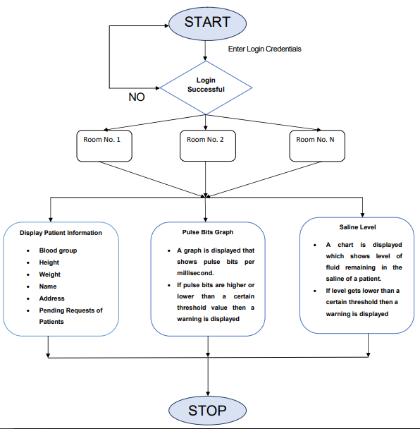

1. **Block diagram of Hardware-Software communication :**

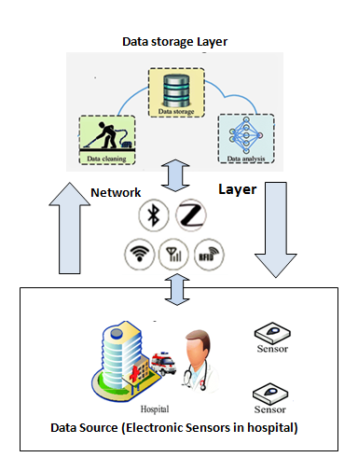

The research in the BD and IOT is rapidly growing and making impact on all areas of businesses and technologies field by increasing the advantages for the organizations and individuals. The growth of data produced via IOT has played a major role on the big data landscape.

Big data can be categorized according to three aspects [6]:

(1) Volume

(2) Variety

(3) Velocity

These categories were first introduced by Gartner to describe the elements of big data challenges [7]. Immense opportunities are presented by the capability to analyze and utilize huge amounts of IOT data, including applications in smart cities, smart transport and grid systems, energy smart meters, and remote patient healthcare monitoring devices. The widespread popularity of IOT has made big data analytics challenging because of the processing and collection of data through different sensors in the IOT environment.

IOT data are different from normal big data collected via systems in terms of characteristics because of the various sensors and objects involved during data collection, which include heterogeneity, noise, variety, and rapid growth.

1. **Data Source (Sensors)**

This layer is responsible for the collecting the data of patient health status and for collecting the data we have used the small and low cost electronic senores. The one sensor is connected to patient body and another one is placed on saline. For connecting both the senores we have built the electronic circuit. It consists of Node MCU, ultra sonic sensor, heart beat sensor.

* Node MCU

NodeMCU is a microcontroller that has capability to connect with internet. It includes firmware which runs ESP8266 Wi-Fi SoC from Espressif Systems, and hardware which is based on the ESP-12 module. The term "NodeMCU" by default refers to the firmware rather than the development kits,The firmware uses the Lua scripting language, It is based on the eLua project, and built on the Espressif Non-OS SDK for ESP8266, It uses many open source projects, such as luacjson and SPIFFS.

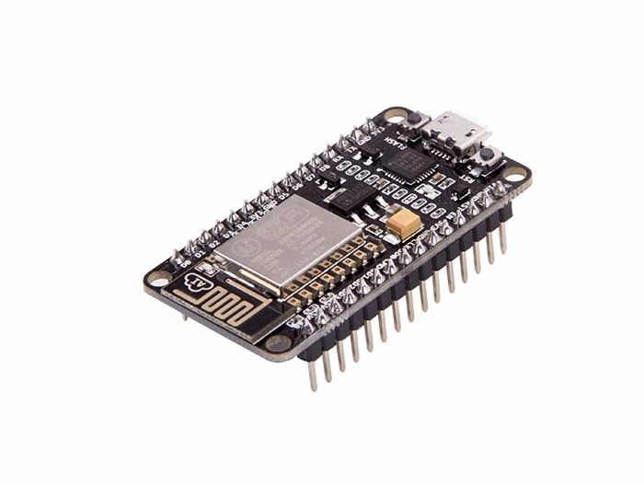

* Heart Beat Sensor

The heartbeat sensor is based on the principle of photo phlethysmography. It measures the

changes in volume of blood through any organ of the body which causes a change in the light Intensity through that organ (a vascular region). In case of applications where heart pulse rate

is to be monitored, the timing of the pulses is more important. The flow of blood volume is

decided by the rate of heart pulses and since light is absorbed by blood, the signal pulses are

equivalent to the heart beat pulses. The detector output is in form of electrical signal and is proportional to the heart beat rate.

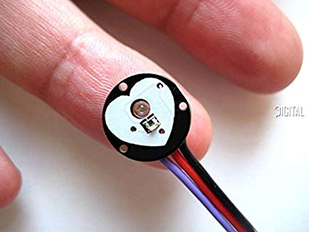

**Way of measure heartbeats**: Hold the senor in between middle of index finger and thumb. So that senor can be measured heartbeat by optical power variation as light is scattered or absorbed during its path through the blood as the heartbeat changes.

* Ultra sonic sensor

The saline water injection plays a key role in the treatment and recovery of many a patient that requires constant monitoring, This condition can be fulfilled by using ultra sonic sensors which can detect a level in the saline bottle. Ultrasonic sensor measure distance by using ultrasonic waves. The sensor head emits an ultrasonic wave and receives the wave reflected back from the target. Ultrasonic Sensors measure the distance to the target by measuring the time between the emission and reception. An optical sensor has a transmitter and receiver, whereas an ultrasonic sensor uses a single ultrasonic element for both emission and reception. In a reflective model ultrasonic sensor, a Single oscillator emits and receives ultrasonic waves alternately. This enables miniaturization of the sensor head.

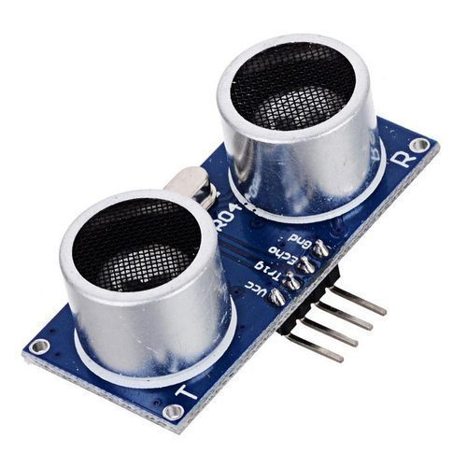

**Way of measure saline level:** The circuit uses an ultrasonic, which is placed in a straight line with the saline bottle at the top of bottle, at the point representing the present saline level. The presence of saline water, in a full bottle, refracts the emitted sound wave frequency, thus generating no output at the sensor. When the saline level falls below the present value; the emitted sound wave reaches the saline level and get reflect toward sensor which is again detect by sensor.

**B. Network layer (IOT)**

Network layer is account for the connectivity of electronic sensors to connect and communicate easily. The ‘thing’ in IOT can refer to any device which is assigned through an IP address. The electronic devices collect and transfers data over the internet without any manual intervention with the help of embedded technology. It helps them to interact with the external environment or internal states to take the decisions. Reference [8] mentioned that IOT could be identified in three model: Sensors, Internet-oriented and knowledge [9]. This layer will gather the data from patient rooms and send it to Blynk server [10]. From Blynk server we have stored these data into BD.

**C. Data Storage Layer (Big Data)**

When we have to grab the data for analysis purpose, IOT is acting as a medium of source for the data, and Due to that, the volume of data generated by sensors or devices that continuously generate large amounts of structured, unstructured, or semi-structured data is stored in Data Base. This massive data is a input for “big data'' [11]. Local database systems are incapable when processing, storing and analyzing fast rising amount of data (Big Data) [12].

**IOT big data processing follows four sequential steps:**

1. The huge amount of unstructured data is produced by IOT devices, which are stored in the big data system.
2. In the big data system which is a shared distributed database, all the data is contained in big data files.
3. Primarily, analyzing the collected IOT big data using analytic tools like spark, Hadoop or MapReduce.
4. At last generate the report of analyzed data for decisions making or for conclusion.

* **BIG DATA ANALYTICS**

Big data analytics is the process of evaluating large data sets that have contained a different type of data types [13] to understand undefined patterns, hidden data relation, patient’s pulse fluctuation [14]. BD analytics depend on some technologies and tools like spark, Hadoop or MapReduce. So that it can convert a huge amount of unstructured and semi-structured data into a more logical and recognizable form for analytical processes. These analytical tools use special algorithms, which is specially design for to discover correlations and patterns over in the data [15]. After completing analyzing, these tool also have the functionality to visualize the in graphs, table and charts for efficient decision making.

**BIG DATA ANALYTICS METHODS**

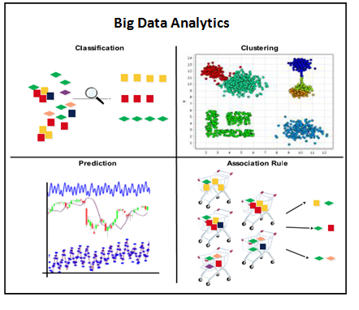

1. **HARDWARE & SOFTWARE**

* **Hardware Required (Minimum):**
* **NodeMCU**
* **Ultrasonic sensors**
* **Heartbeat Sensors**
* **Computer System**
* **Software Specification (Minimum):**

**Operating System:** Windows 10

**Web Application Language:** PHP

**Web Server:** XAMPP server

**Web Browser:** Any browser

# **Conclusion**

Nursing monitoring system is more secure and fast responded as compared to current management in hospital. The advantage of the Nursing monitoring system is there is no need to go to patient room all the time to check the patient saline level and heartbeats. Hence an attempt is made to design a system which helps the hospitals for better monitoring on patients and better managements of hospital rooms. With the help of big data analytics, we can able to keep track of patient’s record in proper manner and also present the data for better visualization and for better diagnosis of disease.

It depends upon how original one could be to enhance the use of this project. This will make nursing work more advance and smarter and help the hospitals for handling the multiple patient health’s’ properly and trying to provide fast treatment. This system can be use in any hospital from small to big range. We can also add many features by adding different sensor in it such as temperature measuring, ECG etc. which will also alert as now we get in existing system. This system will make hospital automated also responsive and error free.

1. References

[1] L. Incipini, A. Belli, L. Palma, R. Concetti, and P. Pierleoni, ‘‘Databases performance evaluation for IoT systems: The Scrovegni chapel use case,’’ in Proc. 42nd Int. Conv. Inf. Commun. Technol., Electron. Microelectron. (MIPRO), May 2019, pp. 463–468.

[2] Peng Li,Yulei Cai , Xiaolong Shen,Sharon Nabuzaale,Jie Yin , and Jiaqiang Li “An Accurate Detection for Dynamic Liquid Level Based on MIMO Ultrasonic Transducer Array”, IEEE transactions on instrumentation and measurement, Vol. 64, No. 3, March 2015.

[3] Cheng xie , Po yang , And Yun yang “Open Knowledge Accessing Method in IoT-Based Hospital Information System for Medical Record Enrichment”, IEEE Special Section On Multimedia Analysis for Internet-Of-Things, Digital Object Identifier 10.1109/ACCESS.2018.2810837.

[4] Gaowei Xu, Yisha Lan , Wen Zhou , Chenxi Huang , Weibin Li , Wei Zhang , Guokai Zhang , E. Y. K. Ng , Yongqiang Cheng , Yonghong Peng , And Wenliang Che, IEEE Special Section On Data-Enabled Intelligence For Digital Health, Digital Object Identifier 10.1109/ACCESS.2019.2957149.

[5] P. Kindt, D. Yunge, A. Tobola, G. Fischer, and S. Chakraborty, ‘‘Dynamic service switching for the medical IoT,’’ in Proc. IEEE Int. Symp. Pers. Indoor Mobile Radio Commun., Sep. 2016, pp. 1–7.

[6]P. Tiainen, ‘‘New opportunities in electrical engineering as a result of the emergence of the Internet of Things’’, Tech.Rep., AaltoDoc, Aalto Univ., 2016.

[7] M. Beyer, ‘‘Gartner says solving ‘Big Data’ challenge involves more than just managing volumes of data’’,Tech.Rep., AaltoDoc, Aalto Univ., 2011.

[8] L. Atzori, A. Iera, and G. Morabito, ‘‘The Internet of Things: A survey,’’ Comput. Netw., vol. 54, no. 15, pp. 2787–2805, 2010

[9] H.-C. Hsieh and C.-H. Lai, ‘‘Internet of Things architecture based on integrated PLC and 3G communication networks,’’ in Proc. IEEE 17th Int. Conf. Parallel Distrib. Syst. (ICPADS), Dec. 2011, pp. 853–856

[10] Online Available: [*https://blynk.io/about*](https://blynk.io/about)

[11] K. Kambatla,‘‘Trends in big data analytics, ’’J.Parallel Distrib. Comput., vol. 74, no. 7, pp. 2561–2573, 2014.

[12] J.Manyika, Big Data: The Next Frontier for Innovation, Competition, and Productivity. McKinsey Global Inst. Rep., 2011.

[13] R. Mital, J.Coughlin, and M.Canaday , ‘‘Using big data technologies and analytics to predict sensor anomalies,’’ in Proc. Adv. Maui Opt. Space Surveill. Technol. Conf., Sep. 2014, p. 84.

[14] N. Golchha, ‘‘Big data-the information revolution,’’ Int. J. Adv. Res., vol. 1, no. 12, pp. 791–794, 2015.

[15] S. Oswal and S. Koul, ‘‘Big data analytic and visualization on mobile devices,’’ in Proc. Nat. Conf. New Horizons IT-NCNHIT, 2013, p. 223.